**LAB MANUAL**



**ROLLNO:AV.SC.U4CSE24322**

**NAME: S .SAI VENKAT**

**SECTION: CSE-B**

**WEEK-1:**

**Aim:** How to install jdk and first program on

printing student details*.*

**Step-1:** Download JDK-21 from oracle website

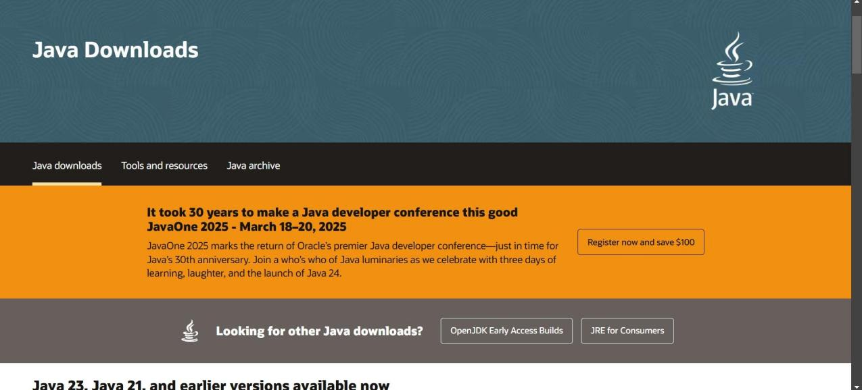

**Step-2:**Install the JDK-21 with accepting terms and

conditions according to the respective windows.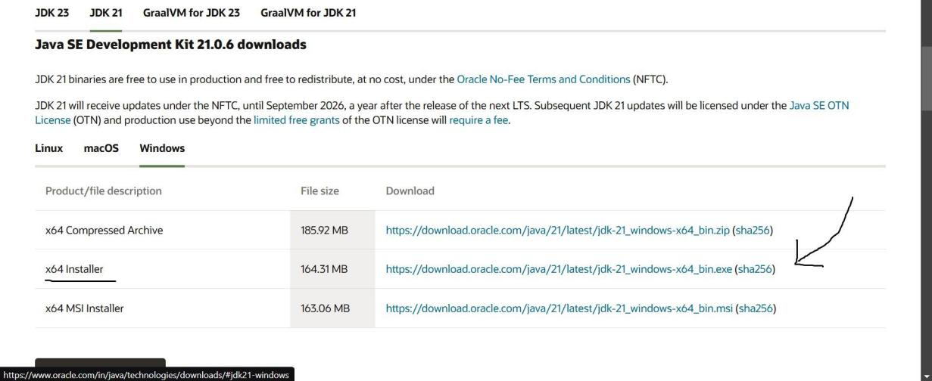

**Step-3**:Setting up environmental variables.

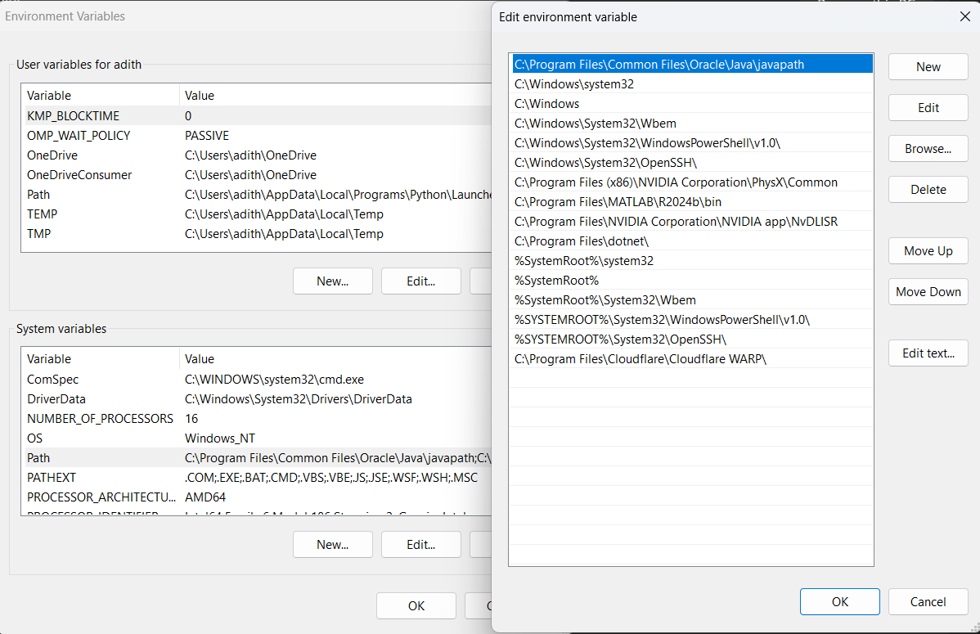

*Windows c -> C-drive -> program files ->Java -

>JDK-21->select bin

*Select and open environmental variable in search

bar-> either select system variables or user

variables-> select path-> click edit->New-> paste

the bin-> finish the setup(apply the changes).

~for verifying the installed version

Open cmd-> type java --version

~command propt

Javac filename.java ->compiling.

Java filename.java ->displaying

**PROGRAM-1(Rectified):**

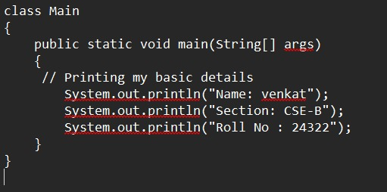

**Output:**

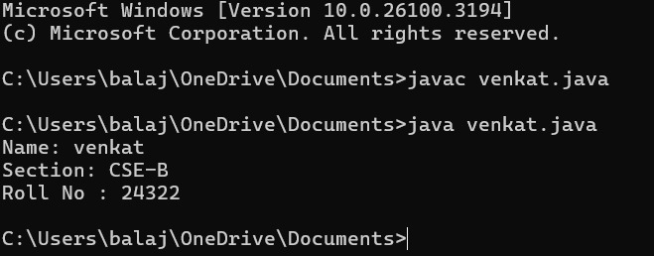***s***

**WEEK-2:**

**PROGRAM-1:**

**Aim:**Write a java program for SI

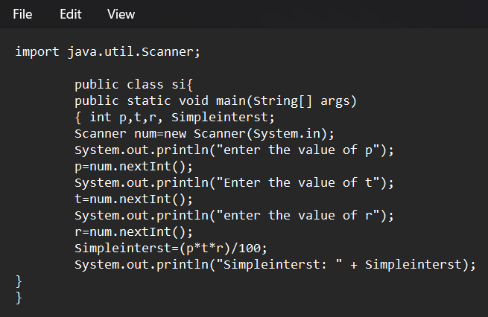

**Output:**

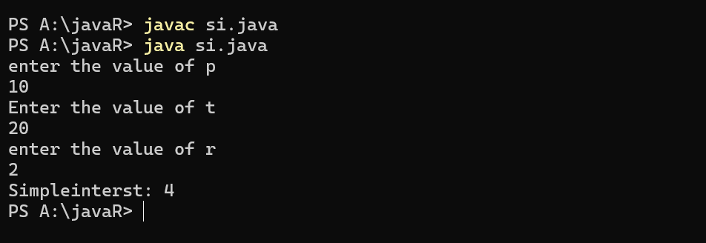

**ERROR TABLE*:***

|  |  |
| --- | --- |
| **Code Error** | **Code rectification** |
| 1.Giving space between next and Double.  2.Not giving parenthesis after closing the input. | 1.Should not give space between next and Double.  2.We must put parenthesis after closing the input. |

**PROGRAM-2:**

**Aim:**Write a program in java for area of

rectangle.

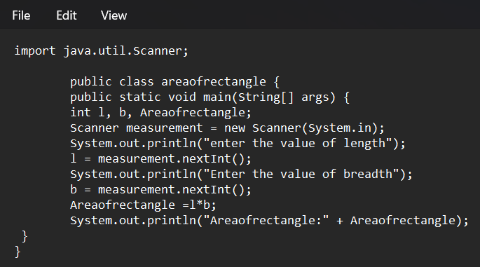

**Output:**

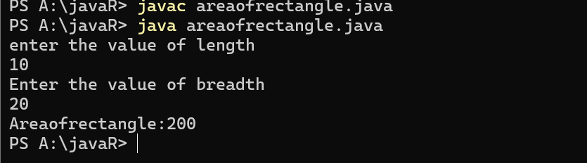

**ERROR TABLE:**

|  |  |
| --- | --- |
| **Code Error** | **Code rectification** |
| 1.While using for iteration, not giving the conditions correctly.  2.Declaring the data type as double instead of int. | 1.We should give iterative statements correctly.  2.We should give the data type as int for integers. |

**PROGRAM-3:**

**Aim:**Write a program in java for area of triangle using heron’s formula.

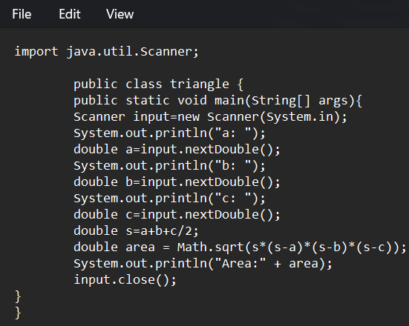

**Output:**

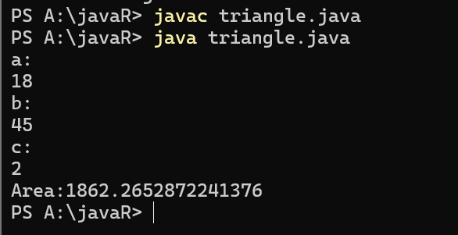

ERROR TABLE:

|  |  |
| --- | --- |
| **Code Error** | Code rectification |
| 1.While printing the variable not giving + sign.  2.Not closing the scanner. | 1.We should give correct indentation.  2.Closing the scanner is must. |

**PROGRAM-4(a):**

**Aim:**Write a program in java for converting temperature from celsius to fahrenite.

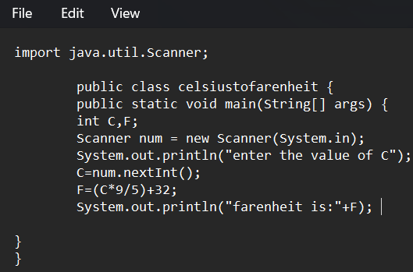

OUTPUT:

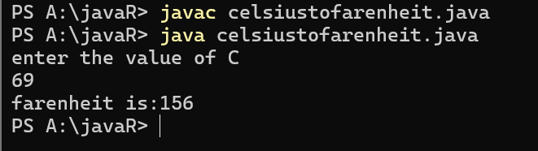

**PROGRAM-4(b):**

**Aim:**Write a program in java for converting temperature from fahrenite to celsius.

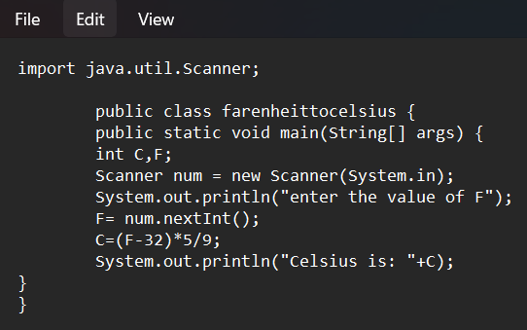

**Output:**

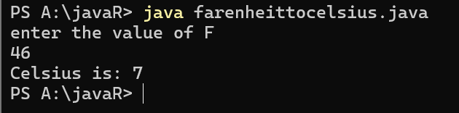

**ERROR TABLE:**

|  |  |
| --- | --- |
| **Code Error** | **Code rectification** |
| 1.While printing the variable not giving + sign.  2.Not closing the scanner. | 1.We should give correct indentation.  2.Closing the scanner is must. |

**PROGRAM-5:**

**Aim:**Write a program in java for factorial of a number.

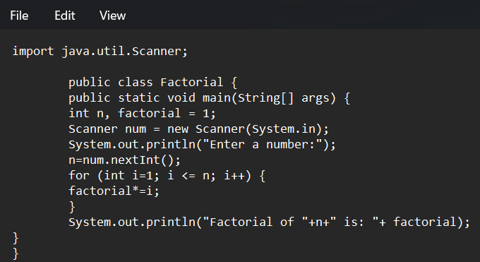

OUTPUT:

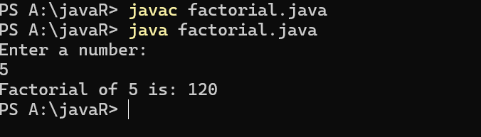

ERROR TABLE:

|  |  |
| --- | --- |
| **Code Error** | **Code rectification** |
| 1.While using for iteration, not giving the conditions correctly.  2.Declaring the data type as double instead of int. | 1.We should give iterative statements correctly.  2.We should give the data type as int for integers. |

**PROGRAM-6:**

**Aim:**Write a program in java for fibonacci series.

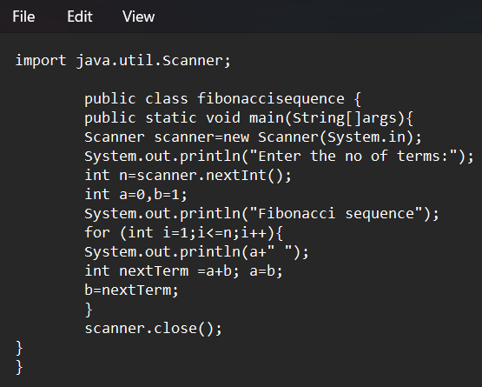

OUTPUT:

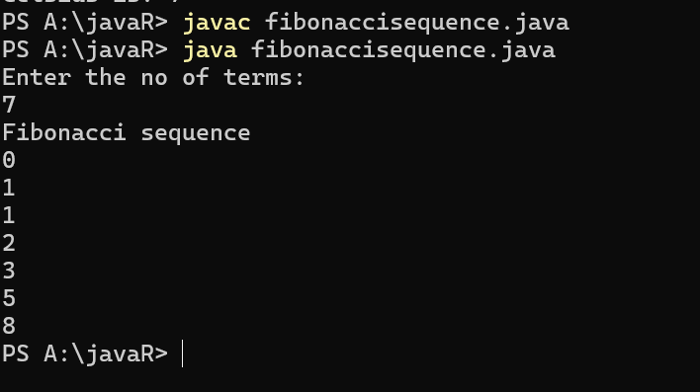

ERROR TABLE:

|  |  |
| --- | --- |
| **Code Error** | **Code rectification** |
| 1.Giving space between next and Double.  2.Not giving parenthesis after closing the input. | 1.Should not give space between next and Double.  2.We must put parenthesis after closing the input. |

**Week 3**

**Program 1:**

**Aim :** Write a java program with the following instructions

1. Create a class with name “Car”
2. Create 4 attributes named CarColor,CarBrand,Fueltype,Miliage
3. Create 3 methods named Start,Stop,Service
4. Create 3 objects named c1,c2,c3
5. Create a constructor with parameters CarColor,CarBrand,Fueltype,Miliage

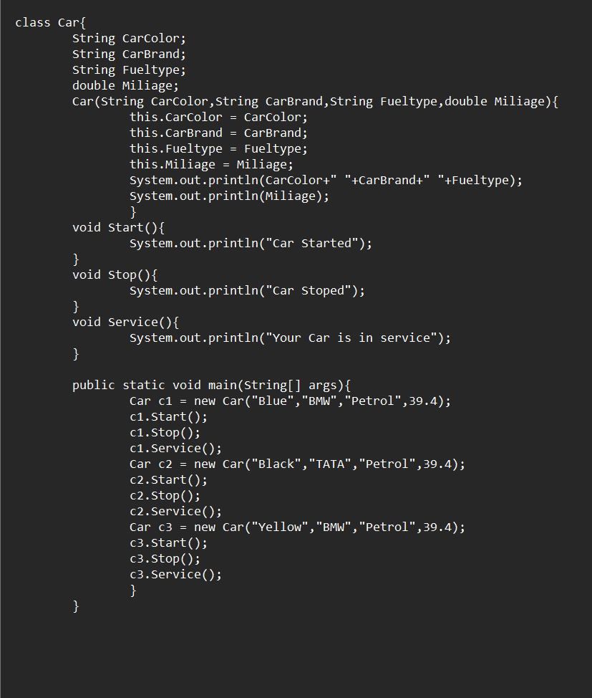

**Output :**

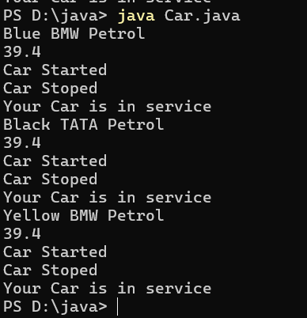

ERROR TABLE:

|  |  |
| --- | --- |
| **Code Error** | **Code rectification** |
| 1.I have kept ‘,’ between variables in print statement | 1.Insted of ‘,’ we should use ‘+’ between  variables in print statement |

**Program 2:**

**Aim:** Create a class named bank account with methods Deposit,withdraw,were the deposit method should accepts a parameter and when this method is called the deposited amount should added to current balance, in addition to that when a withdraw method is called it has to verify where current balance, if current balance is less then withdraw amount , then “There are insufficient funds” message should display.

🡪Use the constructor to display the details of the customer,(Name,AccountNumber,IFSE,Branch)

🡪Also Create two customer objects

**Program:**

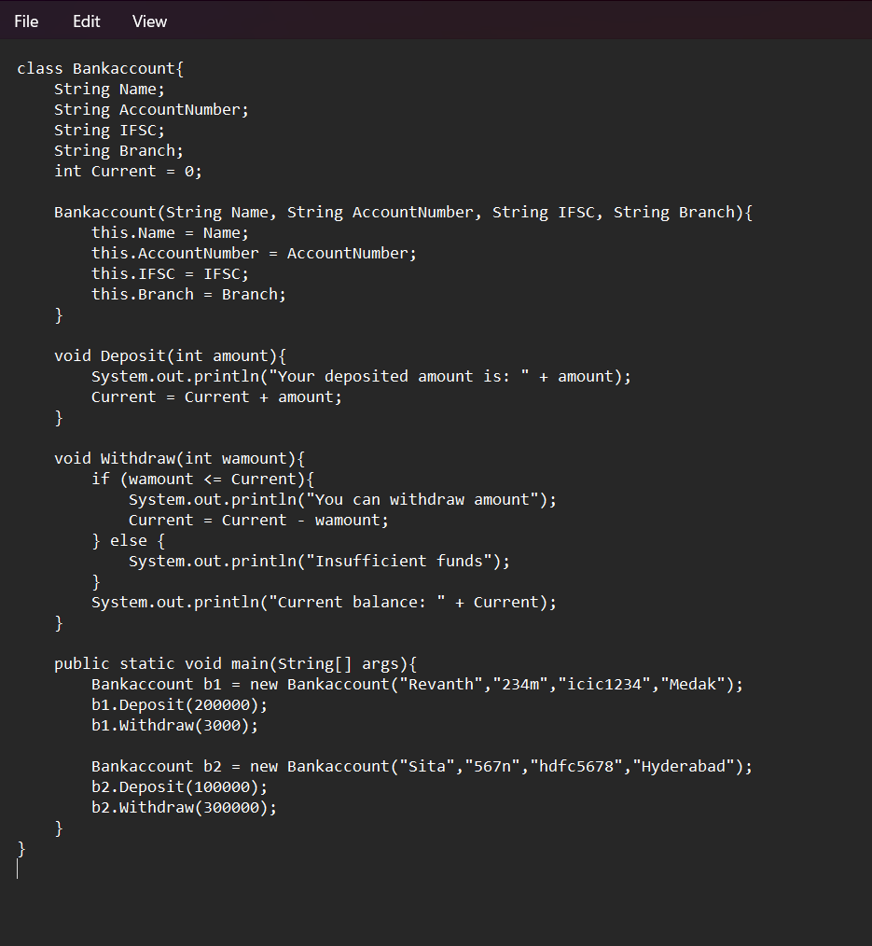

ERROR TABLE:

|  |  |
| --- | --- |
| **Code Error** | **Code rectification** |
| 1. The condition checking in the withdrawal amount should be <= | 1. Change the condition to correct form |

**Output:**

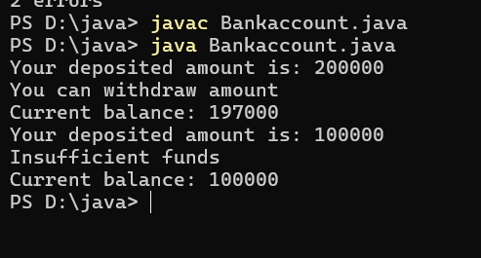

**WEEK-4:**

**PROGRAM-1:**

**Aim:** Write a java program with class named book .The class should contain various attributes such as Title ,Author and Year of Publication .It should also contain a constructor with parameter which initializes Title ,Author and Year of publication .Create a method which displays the details of the book .Display the details of two books.

**CODE:**

class book{

public String title;

public String author;

public String year_of_publication;

public void book(){

this.title=title;

this.author=author;

this.year_of_publication=year_of_publication;

}

public static void main(String[] args){

book book1=new book();

book book2=new book();

book1.book();

book1.title="Sherlock Holmes ";

book1.author="Arthur Conan Doyle";

book1.year_of_publication="1887";

book2.book();

book2.title="Harry Potter";

book2.author="J.K. Rowling";

book2.year_of_publication="1997";

System.out.println("Book-1");

System.out.println("Title :" +book1.title);

System.out.println("Author :" +book1.author);

System.out.println("Year of publication :" +book1.year_of_publication);

System.out.println("Book-2");

System.out.println("Title :" +book2.title);

System.out.println("Author :" +book2.author);

System.out.println("Year of publication :" +book2.year_of_publication);

}

}

**OUTPUT:**

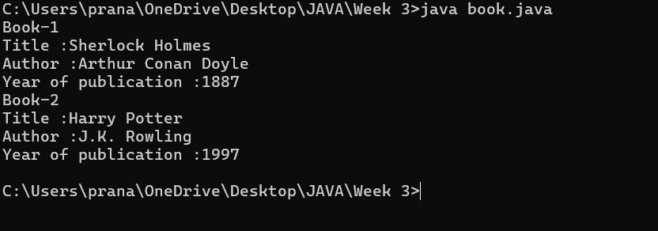

|  |
| --- |
| **Book** |
| * Title: String * Author: String * Year of publication: int |
| + Book(title: String,  Author: String;  Year of publication: int  + displayDetails( ): void |

**Class Diagram:**

IMPORTANT POINTS:

1. While defining two classes for a code, we must be sure that we save both the classes in separate files.
2. While defining a method we should also define a function to call that method.

**Error Table:**

|  |  |  |
| --- | --- | --- |
| **S.No** | **Error** | **Rectification** |
| **1.** | **Missing “;” after calling method.** | **Added “;”** |

**PROGRAM-2:**

**Aim:** Create a java program with class named myclass with a static variable count of int type initialized to 0 and a constant variable “Pi” of type double initialized to 3.14 has attributes of that class .Now define a constructor for “myclass” that incerements the count variable each time an object of myclass is created finally print final values count and Pi variables .Create three objects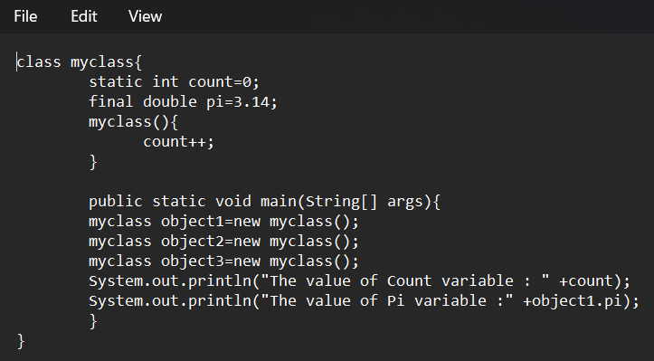

**OUTPUT:**

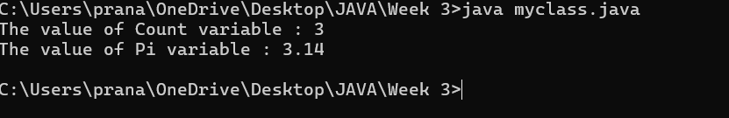

**Class Diagram:**

|  |
| --- |
| Myclass |
| - Count: int  - Pi: double |
| + myclass( )  + main(args: String[]): void |

IMPORTANT POINTS:

1. We must declare the initial value of the variable before declaring the final one.
2. Here the main objective is to increase the count according to the number of objects we make, i.e the count increases when the no.of objects are increasing.

Error Table:

|  |  |  |
| --- | --- | --- |
| S.No | Error | Rectification |

|  |  |  |
| --- | --- | --- |
| 1. | Not typing “}“ at the end of the code. | Added “}”. |